Submitting an Absence Request is more convenient than ever from the browser or the app. Parents can submit and track absence requests for their students. Create requests for full-day absences, late arrivals or early dismissals, select a reason, and upload documentation if required.
Absence Requests
Access the Submit New Absence Request directly under your child’s info on the portal page.
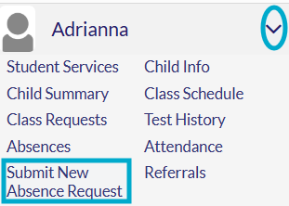
From the Pasco One app:
Select Student More Info Absence Reporting

Click the down arrow next to the selected child
Select Submit New Absence Request menu option
Submitting a New Absence Request

- Click the blue Submit New Absence Request button
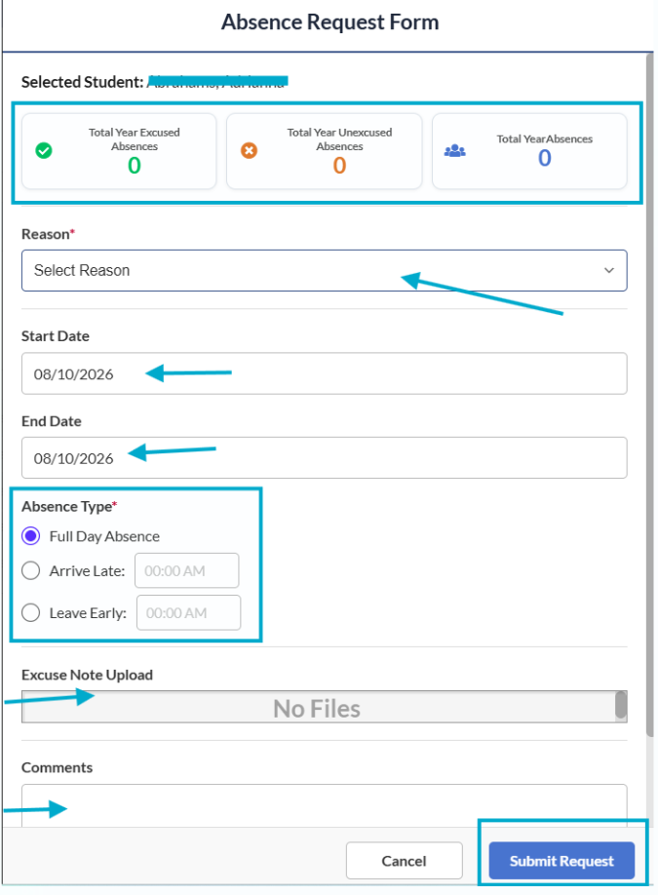
- View summary of absences in the top section
- Select a Reason from the drop-down menu
- Select the Start Date of the absence
- Select the End Date of the absence
- Select the Absence Type
  - Full Day Absence
  - Arrive Late (enter time)
  - Leave Early (enter time)
- Excuse Note Upload (upload as needed)
- Comments – add additional comments that pertain to the absence
- Click Submit Request (request submitted to school)
- Click Cancel to exit the page (no request submitted)
Submitting requests for Unexcused Absences/Tardies
- These are absences already posted to your child’s attendance
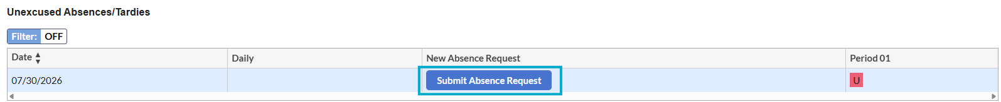
- Click Submit Absence Request
- Complete the Absence Request Form
- Click Submit Request
Reviewing Submitted Requests
- Absence Request History
- Check the Status column for status of submissions
  - Pending
  - Approved
  - Denied
  - Canceled
- Action column
  - Edit or Cancel options available while the request is in pending status and the requested date has not passed
Portal Alerts
Status Updates for:
- Unexcused absences/tardies without Absence Request
- Approval or Denial of Absence Request
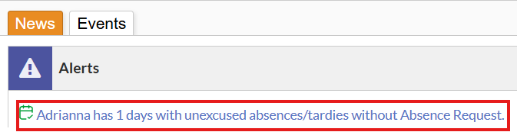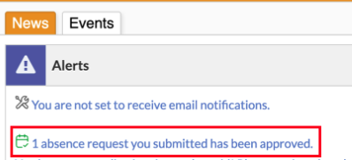
Important:
