Florida Colleges

Broward College
Established: 1960
President: Mr. Gregory Haile
County Served: Broward
954-201-7350
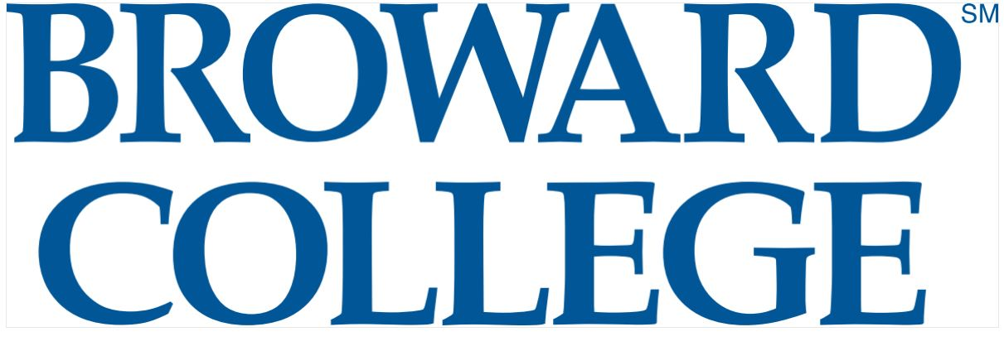
Take a Virtual Tour of Broward College
Chipola College
Established: 1947
President: Dr. Sarah Clemons
Counties Served: Calhoun,
Holmes, Jackson, Liberty, Washington
850-526-2761
Take a Virtual Tour of Chipola College
College of Central Florida
Established: 1957
President: Dr. James D. Henningsen
Counties Served: Citrus, Levy, Marion
352-873-5800
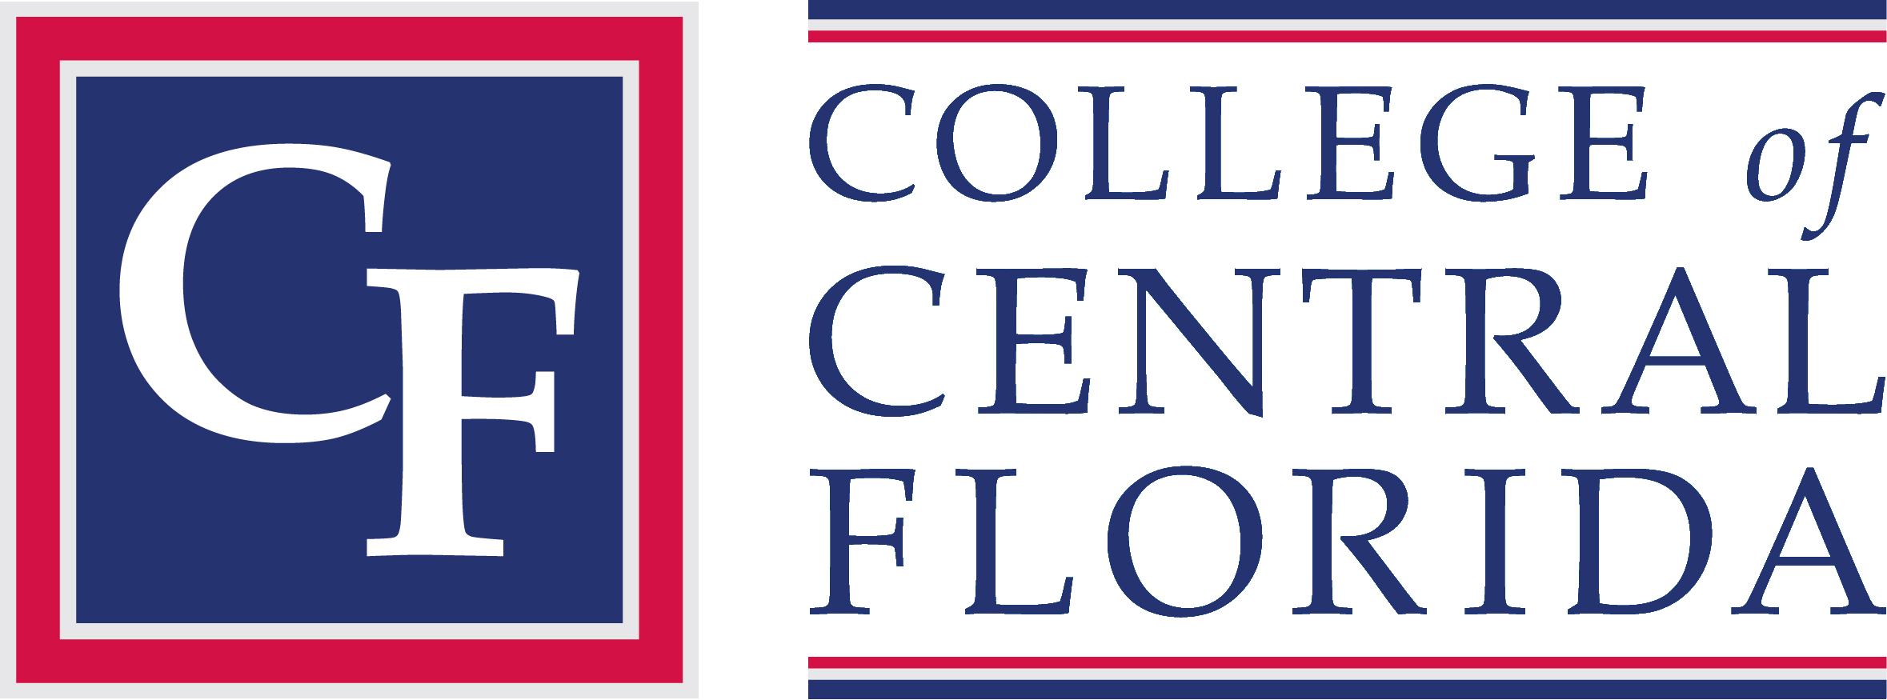
Take a Virtual Tour of College of Central Florida

Daytona State College
Established: 1957
President: Dr. Thomas LoBasso
Counties Served: Flagler, Volusia
386-506-3000
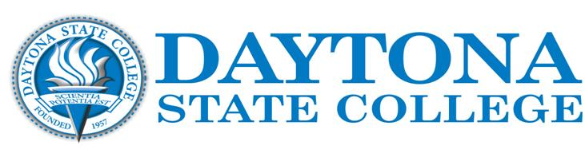
Take a Virtual Tour of Daytona State College
Eastern Florida State College
Established: 1960
President: Dr. James Richey
County Served: Brevard
321-632-1111
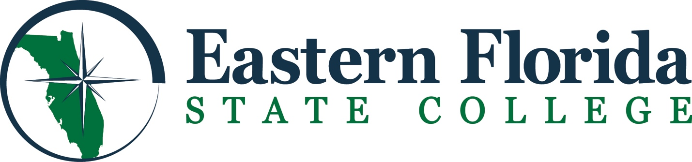
Take a Virtual Tour of Eastern Florida State College
Florida Gateway College
Established: 1947
President: Dr. Lawrence Barrett
Counties Served: Baker, Columbia, Dixie, Gilchrist, Union
386-752-1822
Take a Virtual Tour of Florida Gateway College

The College of the Florida Keys
Established: 1965
President: Dr. Jonathan Gueverra
County Served: Monroe
305-296-9081
Take a Virtual Tour of The College of the Florida Keys
Florida SouthWestern State College
Established: 1962
President: Dr. Jeffery S. Allbritten
Counties Served: Charlotte, Collier, Glades, Hendry, Lee
239-489-9300
Take a Virtual Tour of Florida SouthWestern State College
Florida State College at Jacksonville
Established: 1965
President: Dr. John Avendano
Counties Served: Duval, Nassau
904-632-3222
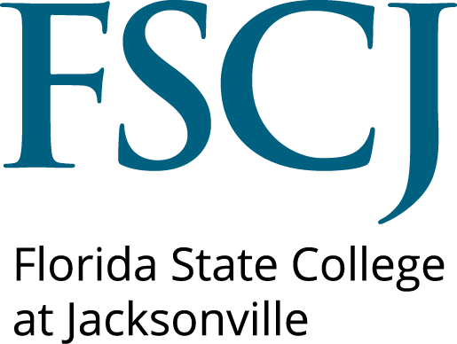
Take a Virtual Tour of Florida State College at Jacksonville

Gulf Coast State College
Established: 1957
President: Dr. John Holdnak
Counties Served: Bay, Franklin, Gulf
850-769-1551
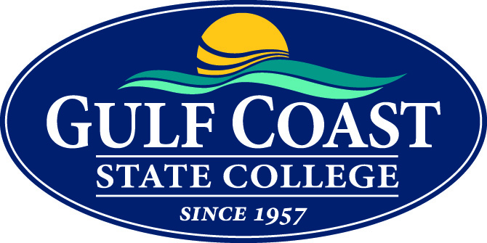
Take a Virtual Tour of Gulf Coast State College
Hillsborough Community College
Established: 1968
President: Dr. Kenneth Atwater
County Served: Hillsborough
813-253-7000
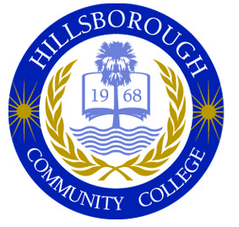
Take a Virtual Tour of Hillsborough Community College
Indian River State College
Established: 1959
President: Dr. Edwin R. Massey
Counties Served: Indian River, Martin, Okeechobee, St. Lucie
772-462-4772
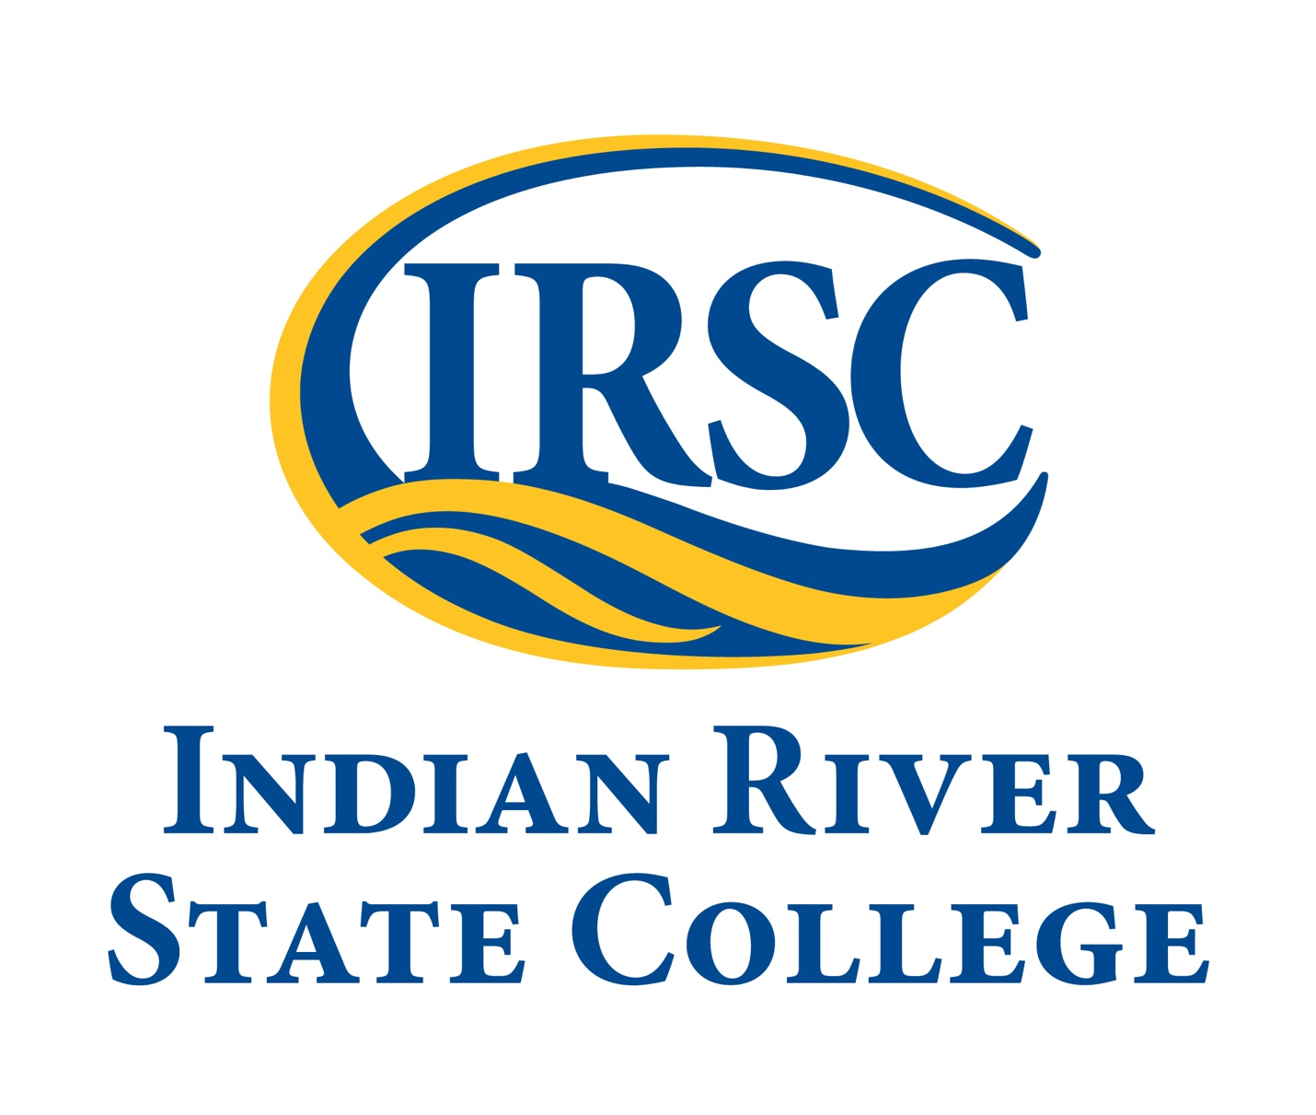
Take a Virtual Tour of Indian River State College

Lake-Sumter State College
Established: 1962
President: Dr. Stanley Sidor
Counties Served: Lake, Sumter
352-787-3747
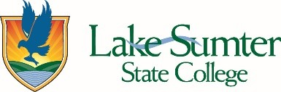
Take a Virtual Tour of Lake-Sumter State College
Miami Dade College
Established: 1960
President: Dr. Rolando Montoya
County Served: Dade
305-237-8888
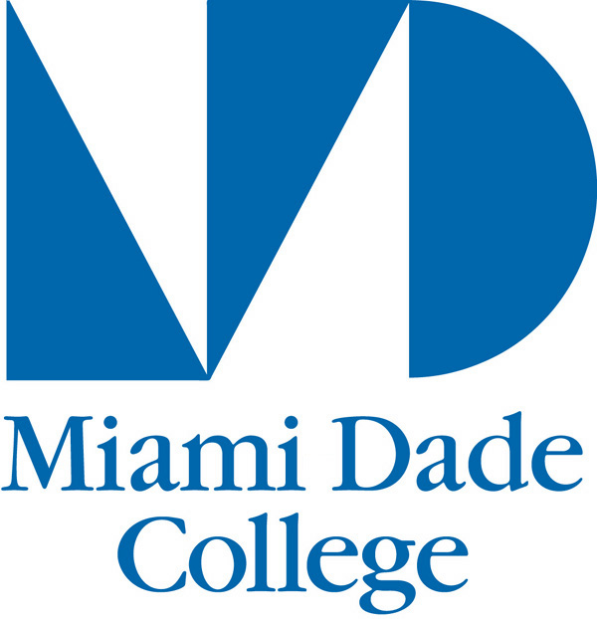
Take a Virtual Tour of Miami Dade College (Kendall Campus)
North Florida College
Established: 1958
President: Mr. John D. Grosskopf
Counties Served: Jefferson, Hamilton, Madison, Lafayette, Suwannee, Taylor
850-973-2288
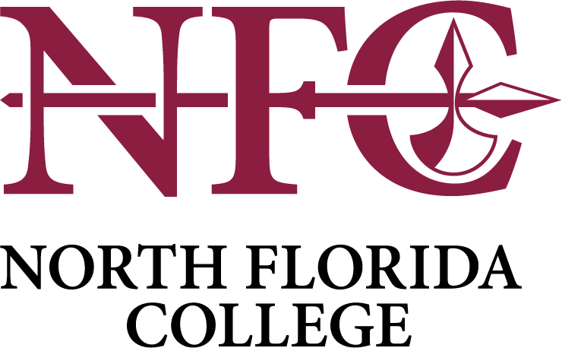
Take a Virtual Tour of North Florida College

Northwest Florida State College
Established: 1963
President: Dr. Devin Stephenson
Counties Served: Okaloosa, Walton
850-678-5111
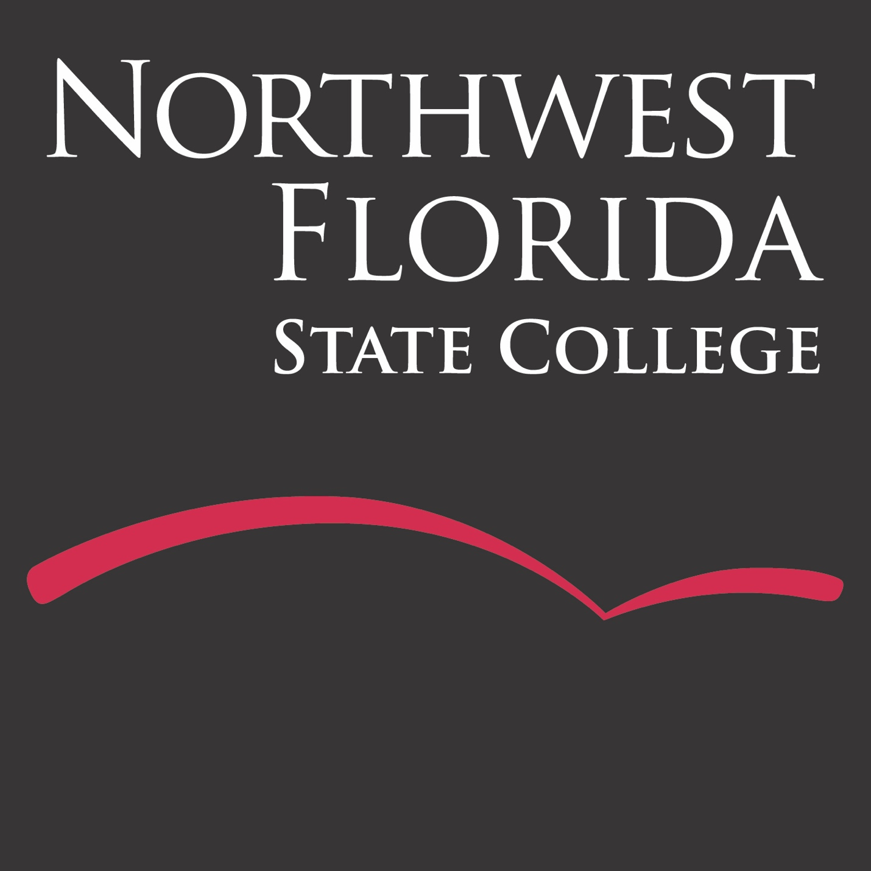
Take a Virtual Tour of Northwest Florida State College
Palm Beach State College
Established: 1933
President: Dr. Ava L. Parker
County Served: Palm Beach
561-868-3350
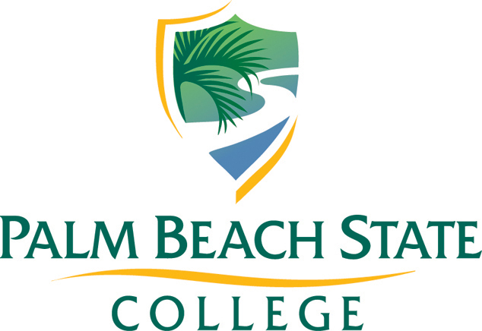
Take a Virtual Tour of Palm Beach State College
Pasco-Hernando State College
Established: 1967
President: Dr. Timothy Beard
Counties Served: Hernando, Pasco
727-847-2727
Take a Virtual Tour of Pasco-Hernando State College

Pensacola State College
Established: 1948
President: Dr. Charles E. Meadows
Counties Served: Escambia, Santa Rosa
850-484-1000
Take a Virtual Tour of Pensacola State College
Polk State College
Established: 1964
President: Dr. Angela M. Garcia Falconetti
County Served: Polk
863-297-1000
Take a Virtual Tour of Polk State College
St. Johns River State College
Established: 1958
President: Mr. Joe H. Pickens
Counties Served: Clay, Putnam, St. Johns
904-276-6800
Take a Virtual Tour of St. Johns River State College

St. Petersburg College
Established: 1927
President: Dr. Tonjua Williams
County Served: Pinellas
727-341-4772
Take a Virtual Tour of St. Petersburg College
Santa Fe College
Established: 1966
President: Dr. Jackson N. Sasser
Counties Served: Alachua, Bradford
352-395-5000
Take a Virtual Tour of Santa Fe College
Seminole State College of Florida
Established: 1965
President: Dr. Georgia Lorenz
County Served: Seminole
407-708-4722
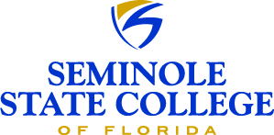
Take a Virtual Tour of Seminole State College of Florida

South Florida State College
Established: 1965
President: Dr. Thomas C. Leitzel
Counties Served: DeSoto, Hardee, Highlands
863-453-6661
Take a Virtual Tour of South Florida State College
State College of Florida, Manatee-Sarasota
Established: 1957
President: Dr. Carol Probstfeld
Counties Served: Manatee, Sarasota
941-752-5000
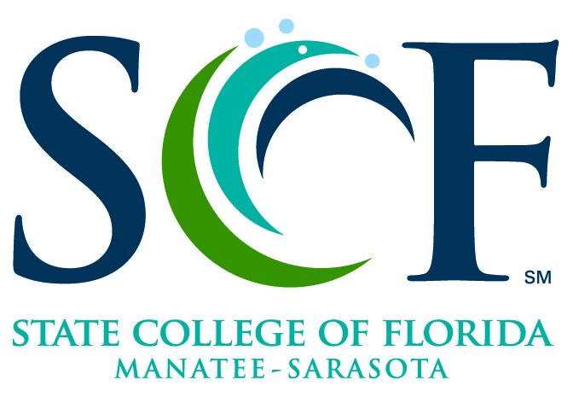
Take a Virtual Tour of State College of Florida, Manatee-Sarasota
Tallahassee Community College
Established: 1966
President: Dr. Jim Murdaugh
Counties Served: Gadsden, Leon, Wakulla
850-201-6200
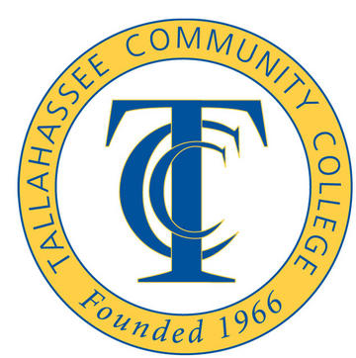
Take a Virtual Tour of Tallahassee Community College

Valencia College
Established: 1967
President: Dr. Sanford C. Shugart
Counties Served: Orange, Osceola
407-299-5000
Take a Virtual Tour of Valencia College

