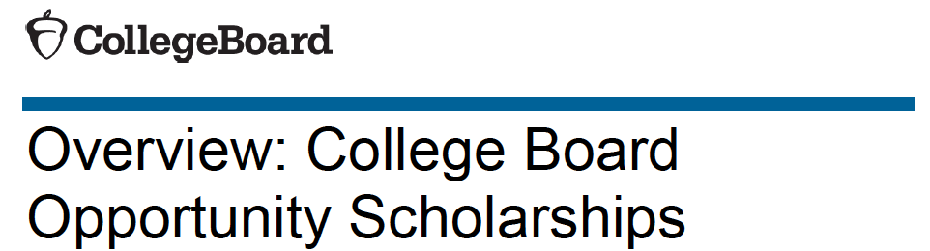

THESE ARE THE 6 STEPS
1. Build Your College List: $500.
▪ _Open December through July of junior year.
▪ _Build a college list with at least 6 schools on BigFuture™.
2. Practice for the SAT®: $1,000.
▪ _Open December junior year through October senior year.
▪ _Use Official SAT Practice on Khan Academy®, and practice for 6+ hours to get ready for test day.
3. Improve Your Score: $2,000.
▪ _Open April junior year through January senior year.
▪ _Improve your score on the SAT by 100 points or more either from PSAT/NMSQT® to SAT or SAT to SAT, after practicing on Official SAT Practice on Khan Academy for 12 hours.
4. Strengthen Your College List: $500.
▪ _Open August through October senior year.
▪ _Make sure your college list has at least 1 safety, 2 match, and 3 reach colleges.
5. Complete the FAFSA®: $1,000.
▪ _Open October through February senior year.
▪ _Fill out the FAFSA form to apply for financial aid.
6. Apply to Colleges: $1,000.
▪ _Open October through February senior year.
▪ _Apply to at least 2 colleges you want to attend.

Complete all 6 steps to be eligible for the Complete Your Journey Scholarship: $40,000.

